**CMPS 350 Project Phase 2 – Report**

**Education Platform**

**(10% of the course grade)**

**The report must be submitted in Word format only**

|  |  |
| --- | --- |
| **Group Members** | Khalid Mahmoud (202207845)  Islam Al-Absi (202209546)  **Emails:** km2207845@qu.edu.qa; ia2209546@qu.edu.qa; |
| **GitHub link** | Give a public link to you code (It is not acceptable to send codes by email) |

**Grades :**

**The student fills only the “Implementation Percentage”: Please specify either: *Working (completed x%)*, *Not Working (completed x%)* or *Not done*.**

|  |  |  |  |  |
| --- | --- | --- | --- | --- |
| **Criteria** | **%** | **Functionality**\* | **Quality of the implementation** | **Grade** |
| Design and implement the Data Model. | 10 |  |  |  |
| Init DB: populate the database with the data from the json files in seed.js | 5 |  |  |  |
| Server actions, APIs and Repository Implementation to read/write data from the database | 25 |  |  |  |
| Statistics use-case with NextJS | 40 |  |  |  |
| **Documentation**  - Data Model diagram.  - UI Design with screenshots and description.  - Database queries.  - Conducted tests and evidence.  - **Contribution** of each team member [-10pts if not done] | 20 |  |  |  |
| **Total** | 100 |  |  |  |
| Copying and/or plagiarism or not being able to explain or answer questions about the implementation. | -100 |  |  |  |

**Important remark: In case of copying and/or plagiarism or not being able to explain or answer questions about the implementation, you lose the whole grade.**

**\* Criteria for grading the functionality:**

- The functionality is working: you get 70% of the assigned grade.

- The functionality is not working: you lose 40% of assigned grade.

- The functionality is not implemented: you get 0.

- The remaining grade in all cases from above **is assigned to the quality of the implementation**,

- The grades are distributed on the various use cases, when the design/implementation is partial, you get only the grades of designed/implemented use cases.

Code quality criteria, include:

- Use of meaningful identifiers for variables and functions (e.g. using JavaScript naming conventions)

- Pages are responsive

- Clean code: simple and concise code, no redundancy

- Clean implementation without unnecessary files/code

- Use of comments where necessary

- Proper code formatting and indentation.

**You lose marks** for code duplication, poor/inefficient coding practices, poor naming of identifiers, unclean/untidy submission, and unnecessary complex/poor user interface design.

**Important Remark**:

**[Grades: 100-85]:** Will be given only to **fully functional application** with **all the quality criteria cited above met** and the project has excellent **design for the various functionalities**. **The report is professional**.

**[Grades: 85-80]:** Will be given only **to functional application** **with most of all the quality criteria cited above met** and the project has good design for the various functionalities. **The report is professional**.

**[Grades: 80-75]:** 80% of the application functionalities are functional. The project respects partially the quality criteria. **The report is professional** but misses some information.

The grades are not negotiable. We expect that only a small portion (around 15%) of the class will be able to meet the criteria for the grades **[100-85]. You should work hard to and demonstrate the merits of your application to earn those grades.+**

# Description of your proposed platform

The proposed platform is a web-based student registration system focused on the backend development of its database and API layer. In this phase, the main goal is to design and implement a relational database using Prisma and SQLite, and to build RESTful API endpoints that interact with student, course, enrollment, and other data. These APIs support core functionalities like retrieving course statistics, tracking student progress, and managing course information.

# Data Model

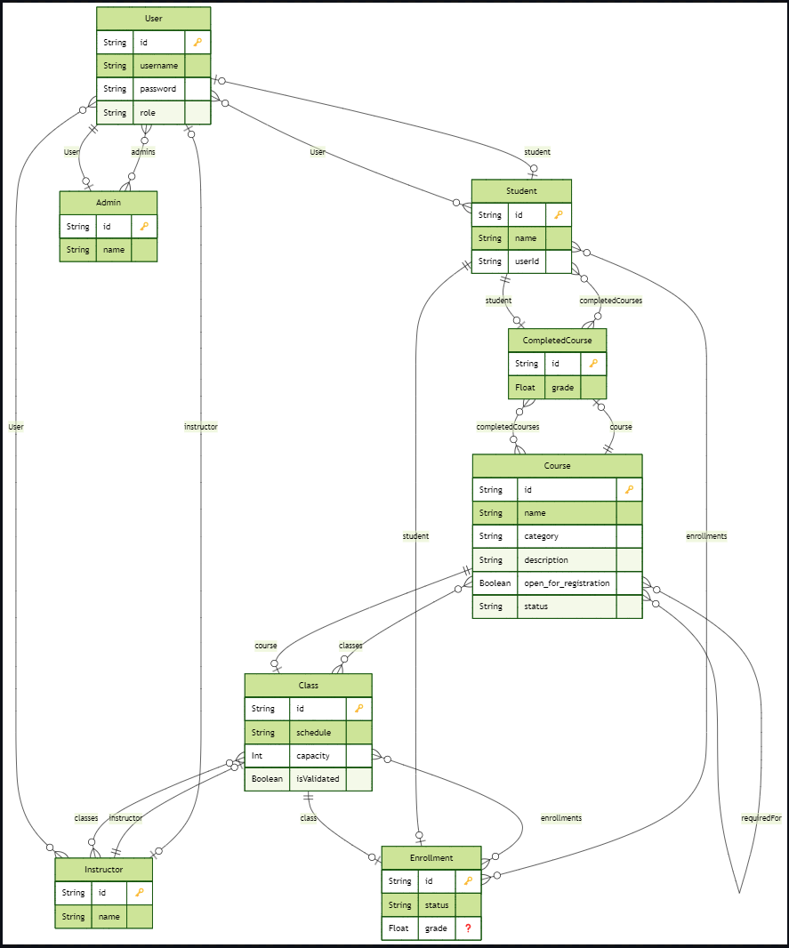

# Web API, Server Actions and repository

List all your implemented methods (functions) to query your data,

Show how you organized them in WebAPI and Server actions

# Implemented statistics use case

# User Interface

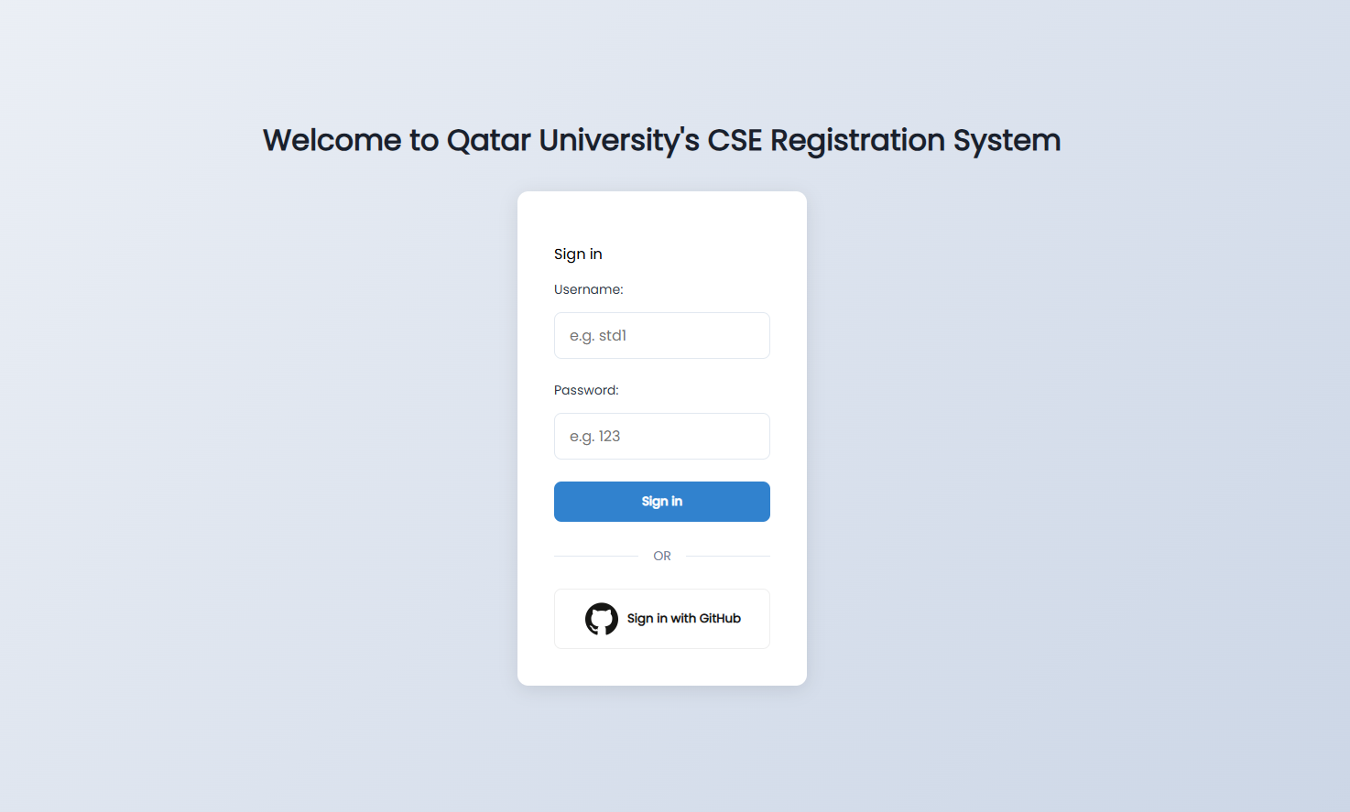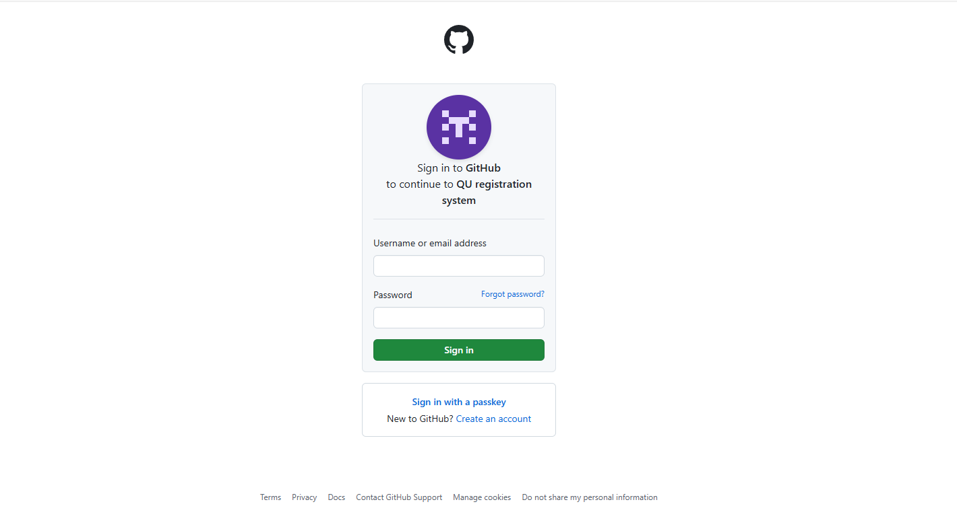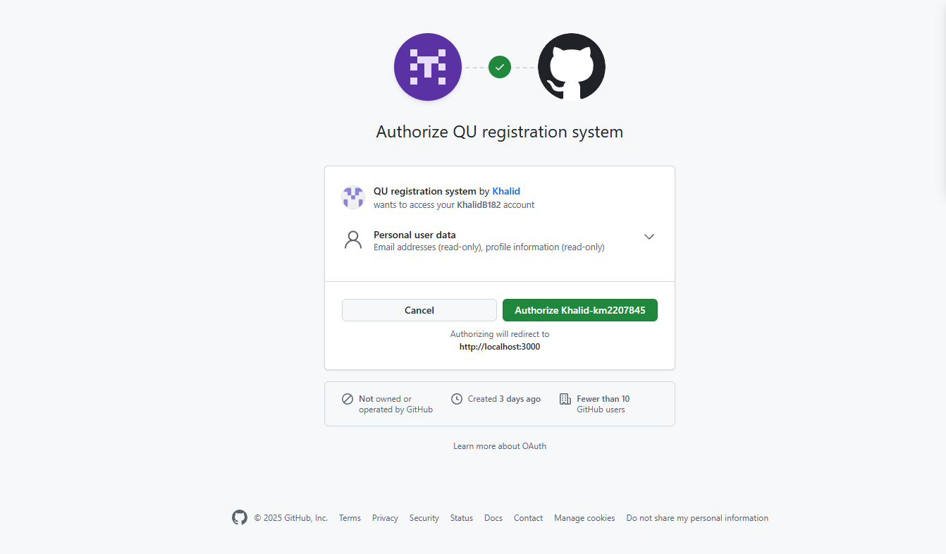

# Implemented queries

# Data used in the statics

Queries were encapsulated in the StatisticsRepo class and are summarized as follows:

**1- Total number of students**

Retrieves the number of all registered students.

**2-Course count per category**

Groups all courses by their category and returns the total count in each category.

**3-Top 3 courses by enrollment count**

Calculates the number of enrolled students in each course and returns the top three with the highest enrollment.

**4-Failure count per course (grade < 2.0)**

Identifies and counts how many students failed each course based on final grades.

**5-Pass count per course (grade ≥ 2.0)**

Groups completed courses by course ID and counts how many students passed.

**6-Class count per instructor**

Calculates how many classes are assigned to each instructor.

**7-Student count per class**

Returns the number of students enrolled in each class.

**8-Top 5 students by GPA**

Computes the GPA of each student and returns the top five students with the highest GPA.

**9-Courses with most failures**

Analyzes each course to determine which has the highest failure rates.

**10-Course status summary**

Groups courses by their status (e.g., active or cancelled) and counts them.

# Conducted tests

# Implemented queries

# Discussion of the project contribution of each team member

|  |  |
| --- | --- |
| **Student name** | **Student contributions** |
| Khalid Mahmoud | • I designed and implemented the database schema using Prisma.  • I handled the login authorization using both credentials and GitHub.  • I developed the main API routes for students, courses, and enrollments etc…  • I contributed to the frontend page design using CSS and React. |
| Islam Al-Absi | * Contributed in API routes * Server Actions * Organized the Repositories |
|  |  |
|  |  |
|  |  |